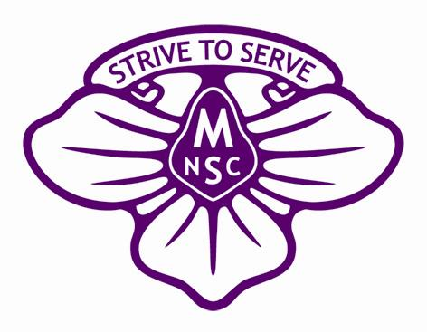
MIRBOO NORTH SECONDARY COLLEGE

James Harvey Trust
Specialist Program Funding Application 2019
James Harvey was a war veteran who lived and farmed in the Mirboo North area for many years. James valued education and the lifelong benefits that students gain through continuing their education beyond the compulsory years. Although James had no children of his own, he firmly believed that opportunities given to students befitted the community as a whole and in his estate left an amount of money to be invested by Mirboo North Secondary College for the purposes of educational scholarships.

The primary objective of the James Harvey Trust Fund is to improve the educational opportunities of enrolled Mirboo North Secondary College (MNSC) students.
The fund provides scholarships and funding for educational purposes and may be granted for activities, resources, programs etc. that assist in the study of subjects on the school curriculum, or other educational subjects approved by the Education Department of Victoria.
Mirboo North Secondary College Council invites applications for James Harvey Trust Specialist Program Funding. It is expected that applications will meet the fundamental conditions of:
- Furthering education in a curriculum subject approved by the Victorian Department of Education
- Providing a program that has educational opportunities for a range of students
Staff co-ordinating Specialist Programs that require additional funding, are required to complete the attached application form.
The completed application form, including any supporting documentation, should be submitted to the James Harvey Trustees by the close of business Thursday 31st October 2019
Applicants may be required to make a presentation of their proposal and/or provide a report at the end of the program or activity, at the discretion of the selection panel.
In assessing applications the following categories will be considered:
- Academic content
- Number of students able to participate
- Other funding sources being utilised
- Involvement with Mirboo North and Districts communities
- College contribution

SECTION A
INFORMATION ABOUT THE PROGRAM
PROPOSED YEAR LEVEL: ___________________________________________
CO-ORDINATING STAFF: ___________________________________________
___________________________________________
___________________________________________
SUMMARY OF PROGRAM:
PROGRAM NAME:
Educational Intent:

Staff may be required to make a presentation of their proposal and/or provide a report at the end of the program or activity, at the discretion of the selection panel.

SECTION B:
BUDGET DETAILS:

OTHER FUNDING BEING SOUGHT:

Students to benefit (if known):

Community and/or Business Partners
SECTION C
JAMES HARVEY SPECIALIST PROGRAM FUNDING REQUEST
- Please name key groups/individuals that may be involved with facilitating your request or that you plan to be working with during the course of the program
Name: ______________________________________ Phone: _____________________________
Name: ______________________________________ Phone: _____________________________
Name: ______________________________________ Phone: _____________________________
Name: ______________________________________ Phone: _____________________________

- Amount being sought from the James Harvey Trust $ ___________________.

Please attach any additional information that you feel may support your application for James Harvey Trust funding.

Signature of staff member responsible for proposed program:

___________________________________ Date: / /

Signature of Principal:

___________________________________ Date: / /

