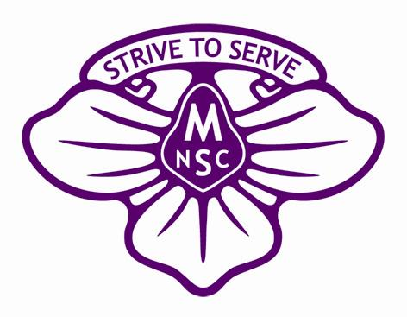
MIRBOO NORTH SECONDARY COLLEGE

James Harvey Trust
Student Scholarship Application
2019
James Harvey was a war veteran who lived and farmed in the Mirboo North area for many years. James valued education and the lifelong benefits that students gain through continuing their education beyond the compulsory years. Although James had no children of his own, he firmly believed that opportunities given to students befitted the community as a whole and in his estate left an amount of money to be invested by Mirboo North Secondary College for the purposes of educational scholarships.

The primary objective of the James Harvey Trust Scholarship Fund is to improve the educational opportunities of enrolled Mirboo North Secondary College (MNSC) students.
The fund provides scholarships for educational purposes and may be granted for activities, resources, programs etc. that assist in the study of subjects on the school curriculum, or other educational subjects approved by the Education Department of Victoria.
Mirboo North Secondary College Council invites applications for James Harvey educational scholarships from students of the college wishing to advance their attainment of specified educational goals. And in particular from students that have an interest in achieving higher educational standards.
It is expected that scholarship applicants will meet the fundamental conditions of:
- satisfactory completion of the previous year level studies
- adherence to the College’s student code of conduct
In addition to school and study specific activities, resources and programs, scholarship awards may be made for such pursuits as:
- attending a community, leadership or global learners’ conference
- student research grants
- increasing appreciation of art, music or literature deemed to be for educational purpose’
- overseas exchanges (students will be required to submit a report at the end of the exchange documenting what they have learnt in their overseas exchange trip)
Scholarship applicants are required to complete the attached application form.
The completed application form, including any supporting documentation, should be submitted to the Mirboo North Secondary College Principal prior to close of business Thursday 31st October 2019.
Applicants may be required to make a presentation of their proposal and/or provide a report at the end of the program or activity, at the discretion of the selection panel.
Applications will be assessed and recommended by the James Harvey Trust board in consultation with the School Principal or delegated representatives thereof.
In assessing applications the following categories will be considered:
- Academic
- Leadership and community service
- Sporting
- The Arts
- College contribution

SECTION A
INFORMATION ABOUT THE CANDIDATE
Given Name(s): ___________________________________________
Family Name: ___________________________________________
Address: ___________________________________________
___________________________________________
________________________Post code __________

Candidate’s signature _________________________________ / /

INFORMATION ABOUT THE PARENT/GUARDIAN
Title: (please circle) Mr / Ms / Mrs
Given Names: ___________________________________________
Family Name: ___________________________________________
Postal Address: ___________________________________________
___________________________________________
_______________________Post code: ___________
Relationship to candidate: ___________________________________________
Home Phone: ___________________________________________
Work Phone: ___________________________________________
Mobile Phone: ___________________________________________
Email: ___________________________________________

I acknowledge and support my child in this application process to gain a James Harvey Trust Scholarship

Parent/Guardian’s Signature: ________________________________ Date: / /

ACADEMIC & ACHIEVEMENT RECORD OF CANDADIDATE
Please list any notable achievements, awards or results you have received

YEAR Achievements, Awards or Results
___________________ ________________________________________________________
___________________ ________________________________________________________
___________________ ________________________________________________________
___________________ ________________________________________________________
___________________ ________________________________________________________
___________________ ________________________________________________________
___________________ ________________________________________________________
___________________ ________________________________________________________
___________________ ________________________________________________________
__________________ ________________________________________________________

SECTION B
JAMES HARVEY TRUST SCHOLARSHIP REQUEST
- Please name key individuals/groups that may be involved with facilitating your scholarship request
Name: ______________________________________ Phone: _____________________________
Name: ______________________________________ Phone: _____________________________
Name: ______________________________________ Phone: _____________________________
Name: ______________________________________ Phone: _____________________________

- Scholarship request amount $ ___________________.

- Please outline:
- What you are seeking the James Harvey Trust Scholarship for,
- How it will improve your future educational opportunities.

Please attach any additional information that you feel may support your application for the James Harvey Trust Scholarship.

Student signature: ___________________________________ Date: / /

