Mirboo North Secondary College 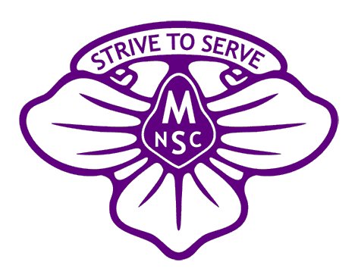
James Harvey Trust
Specialist Program Funding Grant Round 2024

The James Harvey Trust was established in 2018 with a bequeathment of funds from the estate of the late James Harvey. The Trust is managed by a committee comprising staff and school council members of Mirboo North Secondary College as dictated by both legislative requirements and the terms of the will.
Mr. Harvey was a local farmer who believed firmly that gaining an education was vital for students and especially for local students. With no children of his own, he wished to ensure that those who attend Mirboo North Secondary College may pursue opportunities that lead to greater educational learning.

Purpose: The primary objective of the James Harvey Trust Scholarship Fund is to improve the educational opportunities of enrolled Mirboo North Secondary College (MNSC) students.
Funding: Grants will be provided from the interest earned on a corpus of funding invested for this purpose and in accordance with the terms of the trust.
2024 funding pool: Please note that should the program be unable to be conducted, the funding will be reallocated to the pool for the following year as per the terms of the trust and Applicants may reapply for funding should they wish to do so.

Funding Applications open: 18th March 2024
Funding Applications close: 5th April 2024
Funding announcements: 24th of April 2024

Overview:
The fund provides scholarships for educational purposes and may be granted for activities, resources, programs etc. that assist in the study of subjects on the school curriculum, or other educational subjects approved by the Education Department of Victoria.
Mirboo North Secondary College School Council invites applications for James Harvey Specialist Program Funding.
It is expected that applicants will meet at least one of the fundamental conditions of:
- Furthering education in a curriculum subject approved by the Victorian Department of Education
- Provide a program that has educational opportunities for a range of students.
- That cannot be funded through other funding available to Educational Institutions in Victoria

Assessment: applications will be assessed and recommended by the James Harvey Trust board, or delegates appointed by the board in consultation with the MNSC Principal or delegated representative.
Assessment will take into consideration the following categories:
- Academic content
- Number of students able to participate.
- Other funding sources being utilized.
- Involvement of Mirboo North (and catchment area) communities
- College contribution

Assistance to complete the application and/or further information may be obtained via the school office. Please note this will then be referred to those delegates on the assessment panel for provision of further information.
All applications will be treated in accordance with the Privacy Act of 2010
Completed applications will be accepted at the school office or can be emailed to mirboo.north.sc@education.vic.gov.au by the due date.

Mirboo North Secondary College
James Harvey Trust
Specialist Program Funding Grant Round 2024
Application
Applicant details
Given Name(s)
Family Name
Applicant signature
Date
Contact telephone number
Contact email address

Information about the program
Proposed Year level/s
Co-ordinating staff
Program Name
Educational Intent
Summary of program

Scholarship amount requested: $
Budget details (attach detailed budget if applicable and known at this time, including contingency amounts)

Other funding being sought:
Amount | Provider | Expected date of successful application notification

Students to benefit from this application (numbers if known).

Details of any community or business partners involved in this program.
Name | Organization/Business | Contact details

Principal approval:
Signature:
Date:

