Mirboo North Secondary College 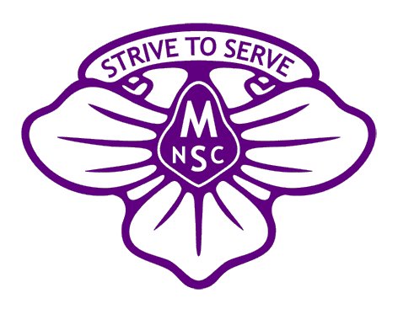
James Harvey Trust
Student Scholarship Grant Round 2024

The James Harvey Trust was established in 2018 with a bequeathment of funds from the estate of the late James Harvey. The Trust is managed by a committee comprising staff and school council members of Mirboo North Secondary College as dictated by both legislative requirements and the terms of the will.
Mr. Harvey was a local farmer who believed firmly that gaining an education was vital for students and especially for local students. With no children of his own, he wished to ensure that those who attend Mirboo North Secondary College may pursue opportunities that lead to greater educational learning.

Purpose: The primary objective of the James Harvey Trust Scholarship Fund is to improve the educational opportunities of enrolled Mirboo North Secondary College (MNSC) students.
Funding: Grants will be provided from the interest earned on a corpus of funding invested for this purpose and in accordance with the terms of the trust.

Funding Applications open: 18th March 2024
Funding Applications close: 5th April 2024
Funding announcements: 24th April 2024

Overview:
The fund provides scholarships for educational purposes and may be granted for activities, resources, programs etc. that assist in the study of subjects on the school curriculum, or other educational subjects approved by the Education Department of Victoria.
Mirboo North Secondary College School Council invites applications for James Harvey educational scholarships from students at the college wishing to advance their attainment of specified educational goals, and in particular from students that have an interest in achieving higher educational standards.
It is expected that applicants will meet the fundamental conditions of:
- Satisfactory completion of the previous year level studies
- Adhere to the MNSC student code of conduct

In addition to school and study specific activities, resources and programs, scholarship awards may be made for such pursuits as:
- Attending a community, leadership, or global learners’ conference
- Student research grants
- Increasing appreciation of art, music or literature deemed to be for educational purposes
- Overseas exchanges
Students will be required to submit a report at the end of the school year documenting their experiences and how the funding has assisted them as part of the acquittal process for this scholarship.

Assessment: applications will be assessed and recommended by the James Harvey Trust board, or delegates appointed by the board in consultation with the MNSC Principal or delegated representative.
Assessment will take into consideration the following categories:
- Academic
- Leadership and community service
- Sporting
- The Arts
- College contribution

Assistance to complete the form may be obtained via the school office.
All applications will be treated in accordance with the Privacy Act of 2010.
Completed applications will be accepted at the school office or can be emailed to mirboo.north.sc@education.vic.gov.au by the due date.

Mirboo North Secondary College
James Harvey Trust
Student Scholarship Grant Round 2024
Student Application
Student details
Given Name(s)
Family Name
Applicant signature
Date
Parent/ Guardian details
Given Name(s)
Family Name
Contact telephone number
Contact email address
Interpreter or Advocate required:  Please note if you require an interpreter or an advocate this can be arranged by the school and will be handled with confidentiality | Yes No
I acknowledge and support the student listed above in this application
Parent/Guardian signature
Date

Academic & achievement record of applicant
Year | Achievements, Awards or results

Barriers to academic achievement that might be considered.

Scholarship amount requested: $
Please outline:
What you are seeking the James Harvey Trust Scholarship for,
And how you envisage the scholarship will improve your future educational opportunities.

Please attach any additional information that you feel may support your application for the James Harvey Trust Scholarship.

Student signature:
Date:

